\*CALL MUSQL stored procedure using LARAVEL.

In this article will explain how to Execute Stored Procedure Using LARAVEL.

**Step 1:**Create Stored Procedure. Follow the link for detail explanation.

**[Create / Execute Stored Procedure in PHP My Admin](https://medium.com/@nishitvmaheta/create-stored-procedures-in-php-myadmin-ccf02c323a7e" \t "_blank)**

[This post will cover how to create Stored Procedures using PHP My Admin. Next part will cover how to execute Stored…](https://medium.com/@nishitvmaheta/create-stored-procedures-in-php-myadmin-ccf02c323a7e" \t "_blank)

[medium.com](https://medium.com/@nishitvmaheta/create-stored-procedures-in-php-myadmin-ccf02c323a7e" \t "_blank)

**Step 2:**Include [LARAVEL’S DB](https://laravel.com/docs/5.8/database) class to the Controller / Model.

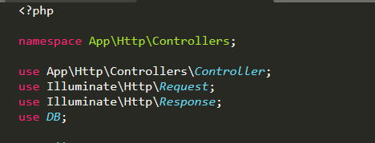

Include DB class

**Step 2:**User **DB: select**to call Stored Procedure. As per the image, calling insert user Stored Procedure which has two parameters (Name, Email).

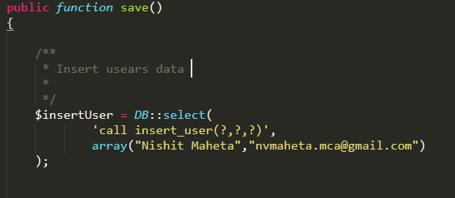

Call Stored Procedure

The first parameter uses **call**keyword to execute Stored Procedure and the second parameter take data in an array format.

That’s it. Hope this article helps you guys to understand **“How to Execute Stored Procedure Using LARAVEL”.**